Computer Architecture Lab
(EL-2012)
LABORATORY REPORT

Fall 2026

(Lab#01)
Apply modern simulation tools ModelSim and
Logisim to implement basic processor components

Student Name: Syed Muhammad Shuja Abbas Naqvi Roll No:24I-6539 Section: A

Date performed: 1st September, 2026

MARKS AWARDED: ________ / 10

Signature and date of Instructor: _________________
Lab Instructors: Dr. Nasir Ali Shah, Engr. Fasih Ahmad

______________________________________________________________________________________________________________________________________________________

NATIONAL UNIVERSITY OF COMPUTER AND EMERGING SCIENCES, ISLAMABAD
Prepared by: | Fasih Ahmad |  | Version: 1.0
Verified by: | Dr. Nasir Ali Shah |  | Updated: Fall 2026

Task 1:

Description:
In this task we Wrote Verilog codes for Basic gates using structural (Gate level) modeling and verifed result,basic gates included AND OR NOT
Code:
module logicgateAND(inputA,inputB,andout);
input inputA;
input inputB;
output andout;
and a1(andout,inputA,inputB);
endmodule

module logicgateOR(inputA,inputB,orout);
input inputA;
input inputB;
output orout;
or a1(orout,inputA,inputB);
endmodule

module logicgateNOT(inputA,notout);
input inputA;
output notout;
not a1(notout,inputA);
endmodule

module testbench();
reg inputA;
reg inputB;
wire AND;
logicgateAND uup(inputA,inputB,AND);
wire OR;
logicgateOR uut(inputB,inputB,OR);
wire NOT;
logicgateNOT abc(inputA,NOT);

initial
begin
inputA=0; inputB=0;
#50 inputA=0; inputB=1;
#50 inputA=1; inputB=0;
#50 inputA=1; inputB=1;
end
endmodule

Output:
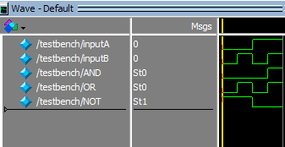

Task 2:

Description:
In this task we Wrote Verilog codes for Basic gates using structural (data flow level) modeling and verifed result,basic gates included AND OR NOT
Code:
module logicgateAND(inputA,inputB,andout);
input inputA;
input inputB;
output andout;
assign andout=inputA&inputB;
endmodule

module logicgateOR(inputA,inputB,orout);
input inputA;
input inputB;
output orout;
assign orout=inputA+inputB;
endmodule

module logicgateNOT(inputA,notout);
input inputA;
output notout;
assign notout=~inputA;
endmodule

module testbench();
reg inputA;
reg inputB;
wire AND;
logicgateAND uup(inputA,inputB,AND);
wire OR;
logicgateOR uut(inputA,inputB,OR);
wire NOT;
logicgateNOT abc(inputA,NOT);

initial
begin
inputA=0; inputB=0;
#50 inputA=0; inputB=1;
#50 inputA=1; inputB=0;
#50 inputA=1; inputB=1;
end
endmodule

Output:
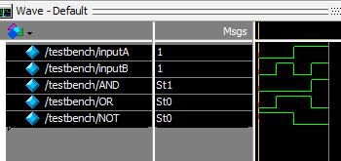

Task 3:

Description:
Here we tested the working of basic gates using logisim and got familiar with the interface and working of the program
Code:
NIL
Output:
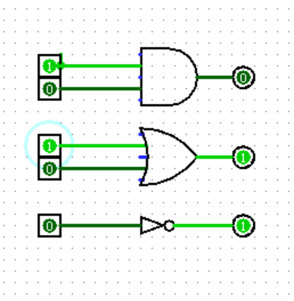

Task 4:

Description:
Here we wrote Verilog code for circuit provided to us using gate level and data flow modeling and verified
results using testbench.

Code:
module logicgateAND(inputA,inputB,andout);
input inputA;
input inputB;
output andout;
and(andout,inputA,inputB);
endmodule

module logicgateOR(inputA,inputB,orout);
input inputA;
input inputB;
output orout;
or(orout,inputA,inputB);
endmodule

module logicgateNOT(inputA,notout);
input inputA;
output notout;
not(notout,inputA);
endmodule

module testbench();
reg inputA;
reg inputB;
wire notA;
logicgateNOT G1(inputA,notA);
wire notB;
logicgateNOT G2(inputB,notB);
wire AnotandB;
logicgateAND G3(notA,inputB,AnotandB);
wire BnotandA;
logicgateAND G4(inputA,notB,BnotandA);
wire finalout;
logicgateOR G5(AnotandB,BnotandA,finalout);
initial
begin
inputA=0; inputB=0;
#50 inputA=0; inputB=1;
#50 inputA=1; inputB=0;
#50 inputA=1; inputB=1;
end
endmodule
DATA FLOW
module logicgateAND(inputA, inputB, andout);
input inputA;
input inputB;
output andout;

assign andout = inputA & inputB;

endmodule

module logicgateOR(inputA, inputB, orout);
input inputA;
input inputB;
output orout;

assign orout = inputA | inputB;

endmodule

module logicgateNOT(inputA, notout);
input inputA;
output notout;

assign notout = ~inputA;

endmodule

module testbench();

reg inputA;
reg inputB;

wire notA;
logicgateNOT G1(inputA, notA);

wire notB;
logicgateNOT G2(inputB, notB);

wire AnotandB;
logicgateAND G3(notA, inputB, AnotandB);

wire BnotandA;
logicgateAND G4(inputA, notB, BnotandA);

wire finalout;
logicgateOR G5(AnotandB, BnotandA, finalout);

initial
begin
inputA = 0; inputB = 0;
#50 inputA = 0; inputB = 1;
#50 inputA = 1; inputB = 0;
#50 inputA = 1; inputB = 1;
end

endmodule

Output:
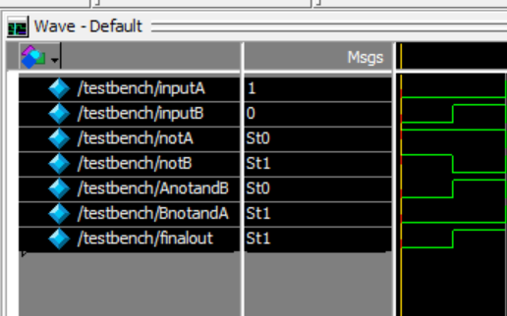

Task 5:

Description:
We recreated the circuit on logisim
Code:
NIL
Output:
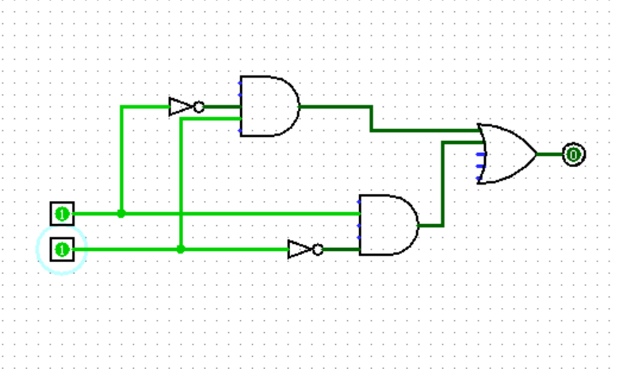

Task 6:

Description:
Wrote Verilog code to find 1’s complement of four bits using gate level and data flow
modeling. Verified results using testbench.

Code:
module compliment(inputA,outputA);
input [3:0] inputA;
output [3:0] outputA;
not(outputA[0],inputA[0]);
not(outputA[1],inputA[1]);
not(outputA[2],inputA[2]);
not(outputA[3],inputA[3]);
endmodule

module testbench();
reg [3:0] inputA;
wire [3:0] outputA;
compliment G1(inputA,outputA);

initial
begin
inputA = 4'b0000;
#50 inputA = 4'b0001;
#50 inputA = 4'b1010;
#50 inputA = 4'b1111;
end

endmodule
DATA FLOW

module compliment(inputA,outputA);
input [3:0] inputA;
output [3:0] outputA;
assign outputA[0]=~inputA[0];
assign outputA[1]=~inputA[1];
assign outputA[2]=~inputA[2];
assign outputA[3]=~inputA[3];
endmodule

module testbench();
reg [3:0] inputA;
wire [3:0] outputA;
compliment G1(inputA,outputA);

initial
begin
inputA = 4'b0000;
#50 inputA = 4'b0001;
#50 inputA = 4'b1010;
#50 inputA = 4'b1111;
end

endmodule

Output:
